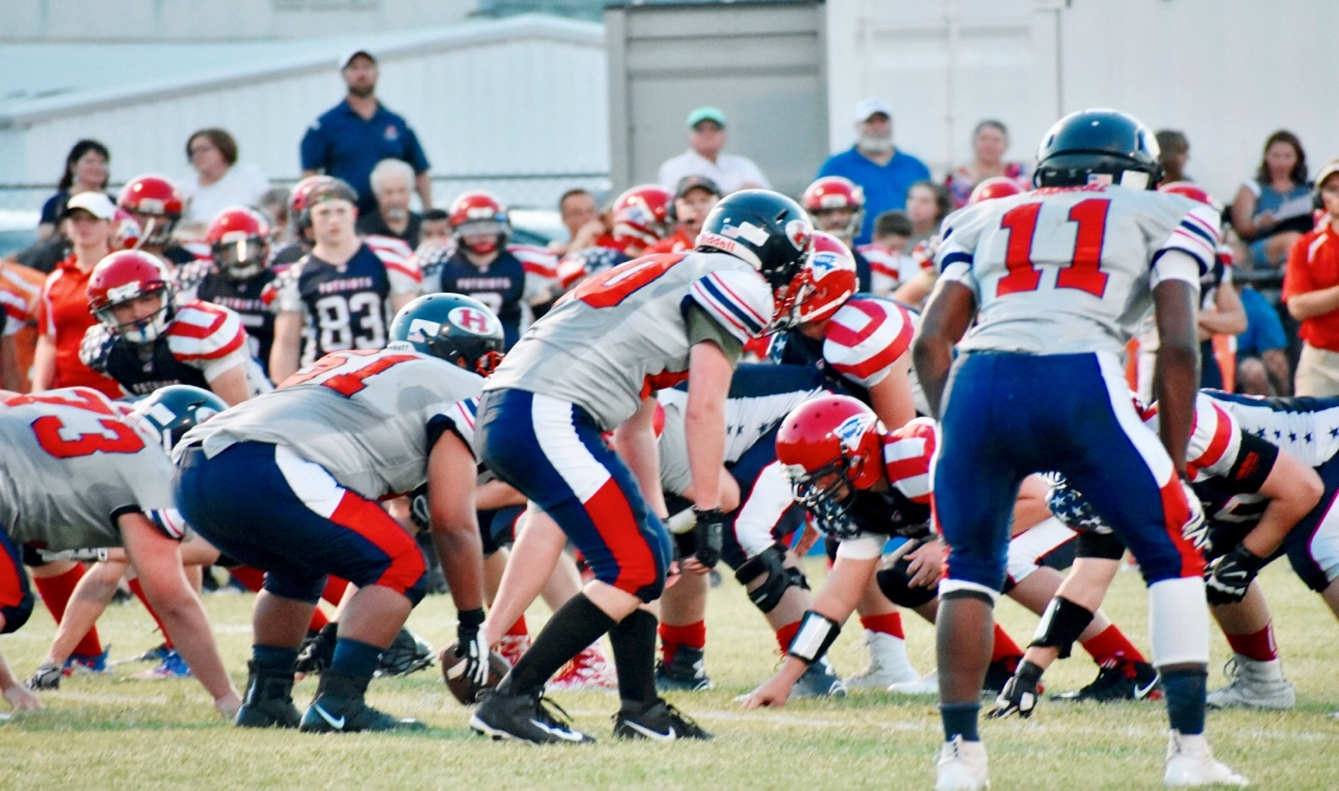

HSAA VARSITY 2019

GAME SCHEDULE
FRIDAY 8/30 HSAA ALL SPORT PEP RALLY
9/6 HOME GAME vs OKC Patriots 7:30 kick off
9/13 HOME GAME vs Fort Worth Rattlers 7:30 kickoff
9/20 HSAA @ Texas Wind 7:00 3201 S New Road, Waco, TX
9/27 HSAA HOMECOMING vs NICH 7:30 kickoff
10/4 HOME GAME vs DasCHE 7:30 kickoff
10/ 11 HSAA @ Northside 7:00, Conroe, TX
10/18 HOME GAME vs Cathedral High (El Paso) 7:30 kick off
10/25 HSAA vs Fellowship Christian 7:00 @ Lone Star (Fellowship is the Home team)

11/2 TEXAS HOMESCHOOL STATE PLAYOFFS
11/9 TEXAS HOMESCHOOL STATE PLAYOFFS

11/20-24 NATIONAL HOMESCHOOL FOOTBALL TOURNAMENT Panama City Bch, FL

