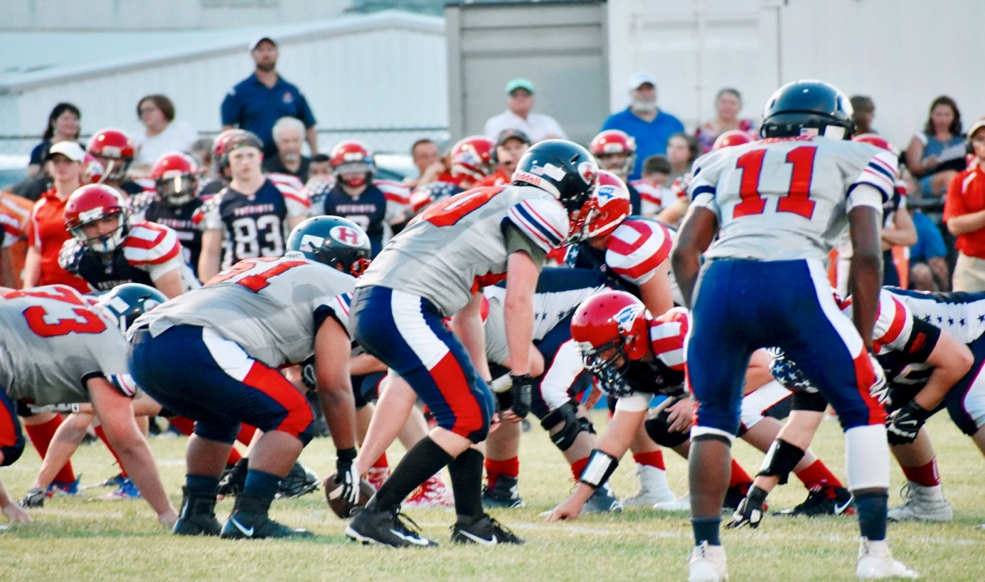

HSAA Middle School 2019

GAME SCHEDULE

8/24 Scrimmage 1 vs Atlas 9:30am
8/29 Scrimmage 2 vs McCowan Middle School 5:30 1500 Majestic Meadows, Glenn Heights
FRIDAY 8/30 HSAA ALL SPORT PEP RALLY
9/6 HOME GAME vs OKC Patriots 5:30 kick off
9/13 HOME GAME vs Fort Worth Rattlers 5:30 kickoff
9/20 HSAA @ Texas Wind 5:00 3201 S New Road, Waco, TX
9/27 HSAA HOMECOMING vs NICH 5:30 kickoff
10/4 HOME GAME vs Newman International Arlington 5:30 kickoff
10/ 11 BYE (TBD)
10/18 BYE (TBD)
10/24 HSAA @ Episcopal School Dallas 5:00 4100 Merrell Rd, Dallas

